IT 55
ADVANCED WEB DEVELOPMENT
FINAL PROJECT DOCUMENTATION

JobMatch: A Web-Based Job Hiring and Application System

MEMBERS
De Vero, Eunice Jayce F. - Project Manager / UI/UX Designer / Full Stack Developer
Bertoldo, Gabriel – Tester
Dantes, Karl P. – Tester
Dela Cruz, James Louie – Tester
Dizon, Jayem C. - Back-End Developer
Estrella, Rain Justine - Front-End Developer
Zamora, Jerwin L. - Front-End Developer / UI/UX Designer

November 5, 2025

Project Description
JobMatch is a web-based platform designed to connect employers and job seekers in an easy and simple way. The website system can be accessed by the two types of users, the Employers and Job Seekers that have their own different dashboard. It allows the employers to post job openings, view the applicants, and manage the hiring process. Applicants on the other hand can look for job posts, apply for the job, upload their resumes, and get updates about their application status.
The purpose of JobMatch is to make the hiring process and job search more easier, faster, and organized. It gives both users, the employers and applicants a place to update the process about the job. Also, it aims to solve the problem of time consuming and unorganized hiring process where employees need to do all the needed requirements manually, it also prevents the hassle to check one by one of the applicants for the employers, and also to give opportunities for applicants that is having a hard time searching in different kinds of websites and social medias to find job openings. JobMatch can easily save time and effort for both users, from posting and finding jobs to applying and getting updates.

Project Objectives
- To develop a web system that has dual-user for both employer and job seeker that allows to create and manage their accounts
- To design a web system that has dashboard where it allows the employer to post a job listings , view applicants, and manage the hiring process, while the job seeker can apply and submit the needed requirements.
- To create a search engine that has filter features (job type and category) for applicants to find job postings based on their preferences.
- To implement a notification system that updates the applicants regarding the status of their applications.

Target Users
- Employers - organizations or individuals that advertise and post job openings and hire qualified talents.
- Job Seekers - individuals that are looking for opportunities to work full time, part time, or gig.

System Features
User
Information Module
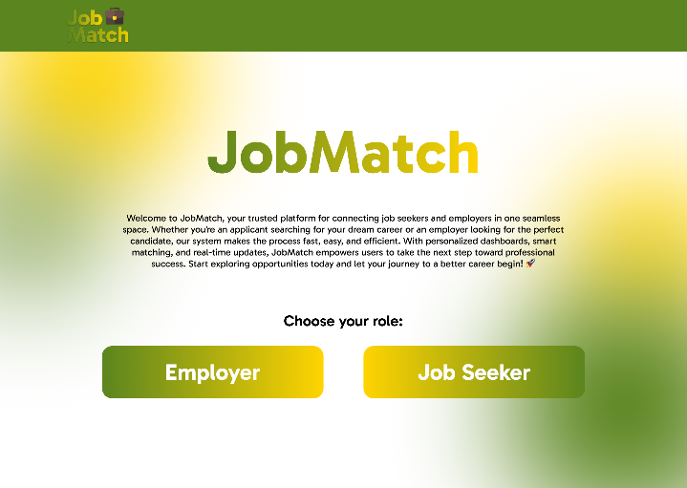
Functionalities
  - This module is the first the user will see after they enter the website. It serves as an information whether the user wants to create an account as an Employer or Job Seeker by clicking the chosen the buttons.

Login Module
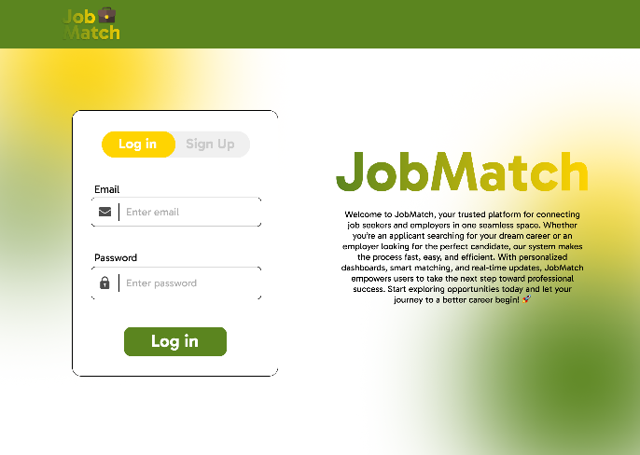
Functionalities
  - After the user click the preferred button on the information page it direct to Log in module where the authentication happened.

Sign Up Module
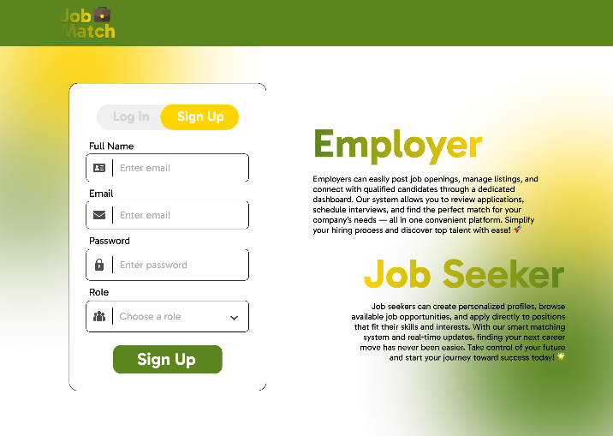
Functionalities
  - This module is where the users can create an account and select a role they preferred its either an Employer or Job Seeker.

Job Seeker Dashboard Module
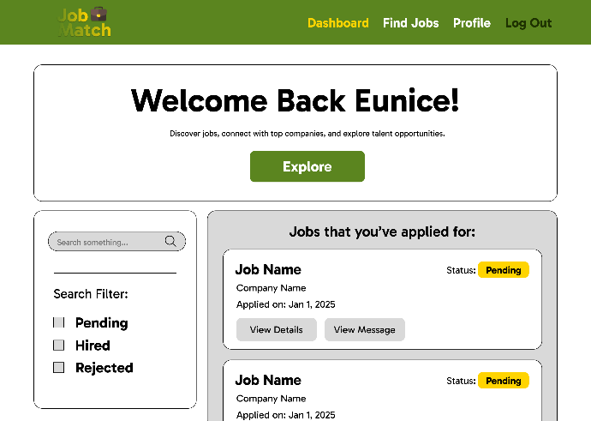
Functionalities
  - This module is where the users can see the jobs they have already applied, also they can see the message that has been sent by the company, it has also search engine with search filters so they can easily search the job name or to filter on what status they have receive on their application.

Message Received Module
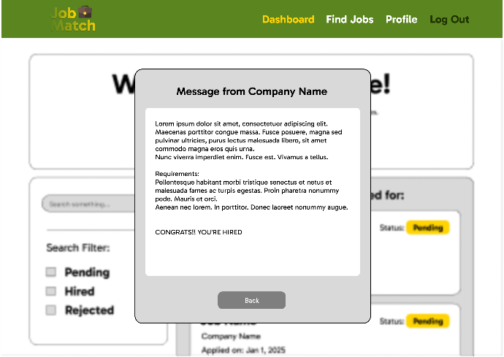
Functionalities
  - This module is where the user can see the sent message from the Employer.

Find Jobs Module
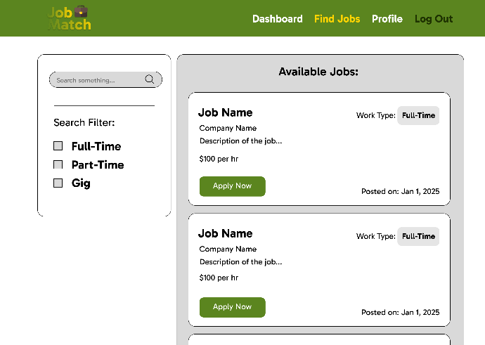
Functionalities
  - This module is where the users can find jobs posted by the employer, they can apply jobs by clicking the “Apply Now” button. Also they can search the job they want and can filter the job category that they preferred.

Apply Form Module
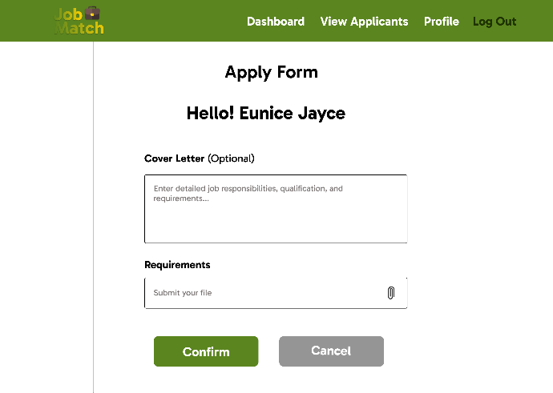
Functionalities
  - This module is where the user can fill the form for application that the job post requires.

Job Seeker Profile Module
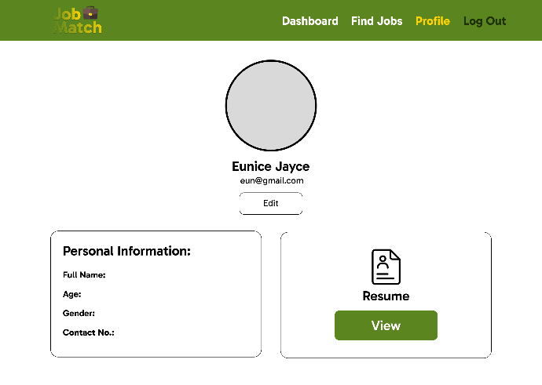
Functionalities
  - This module is where it allows the user to view their information and resume.

Job Seeker Edit Information Form Module
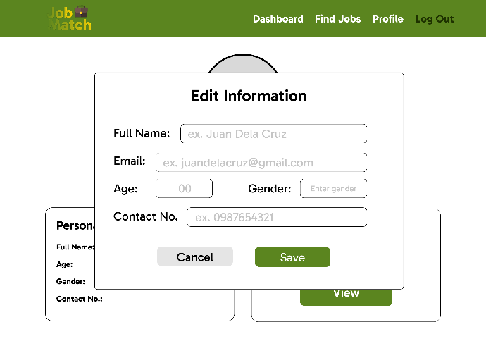
Functionalities
  - This module is where it allows the user to edit their information.

Job Seeker Logout Module
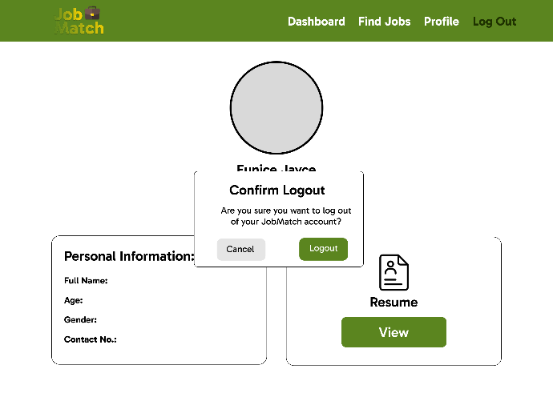
Functionalities
  - This module is where it ask the user if they are actually logging out on the website.

Employer Dashboard Module
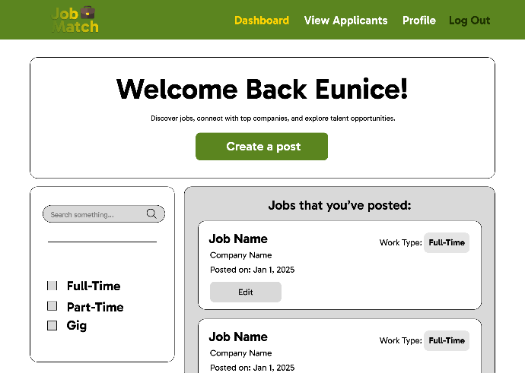
Functionalities
  - This module is where the user can create a post and see the job post they have made and can also edit them, it also has search engine and filter to see the job category post they created.

Create a New Job Listing Form Module
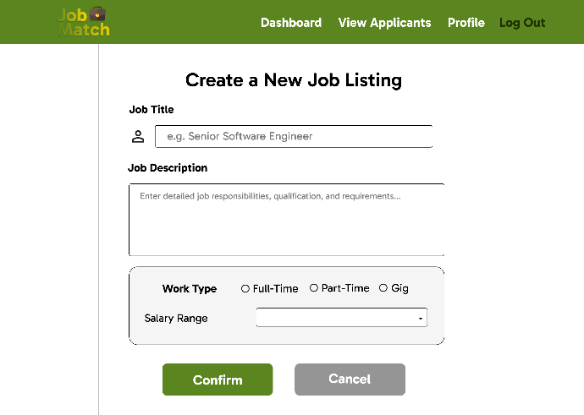
Functionalities
  - This module allows the user to create a job post and post them for job seekers to see.

View Applicants Module
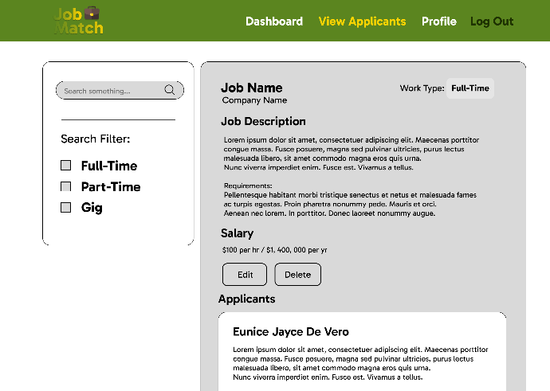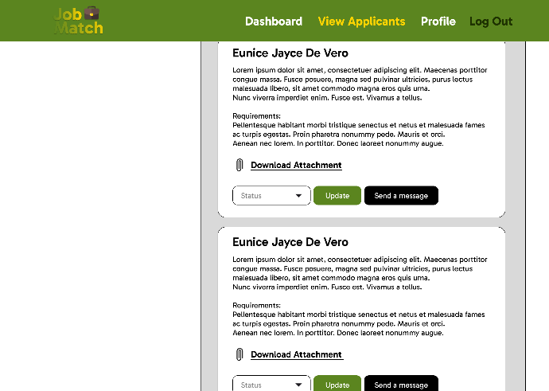

Functionalities
  - This module allows the user to see all the applicants that applied on the job post they have created, and also can edit or delete the post. It has search engine and filter for the user can easily find the specific post they have created. Also it has an status update button for the employer to update the applicants on their status on their application. They can also download the attachment that the applicant submit on their job posting.

Send Message Module
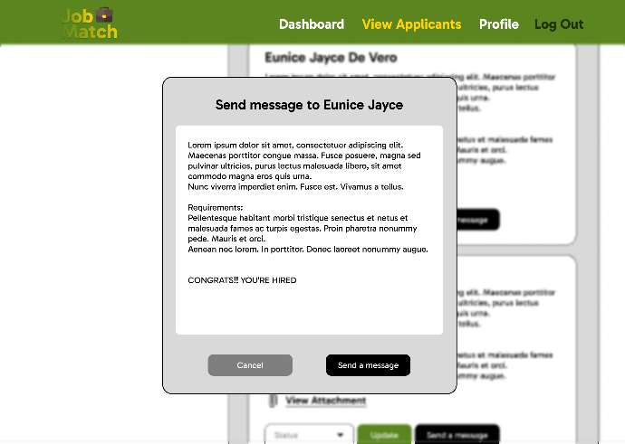
Functionalities
  - This module allows the user to send a message to the applicants to update their status regarding to their job application.
Employer Profile Module
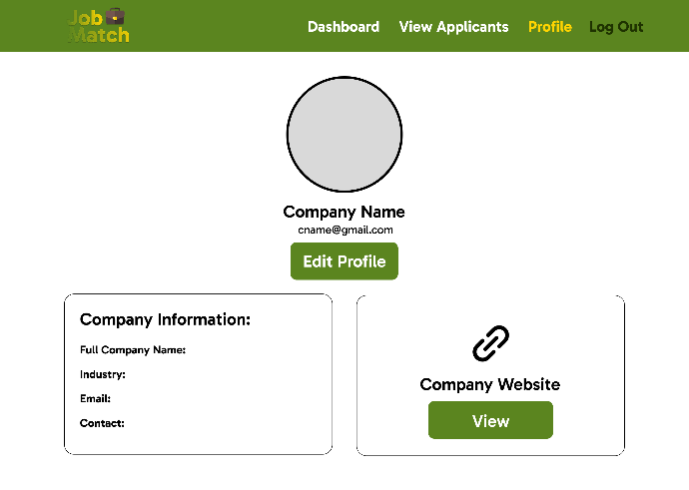
Functionalities
  - This module is where it allows the user to view their information and websites they put on their profile.

Employer Edit Information Form Module
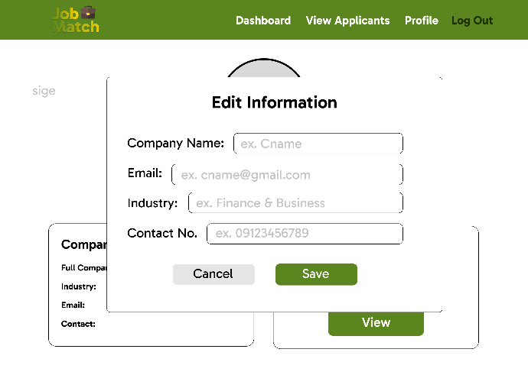
Functionalities
  - This module is where it allows the user to edit the information in their profile.

Enter Website Link Module
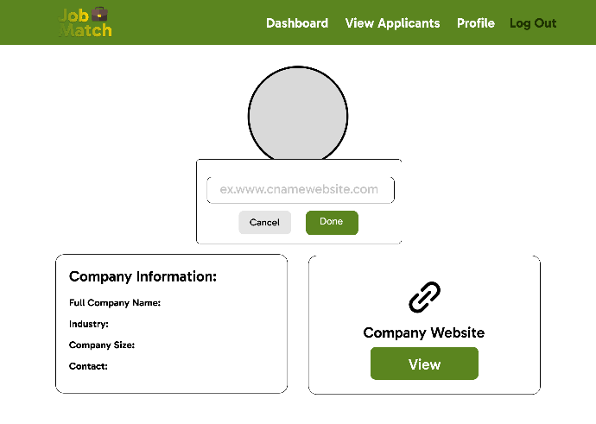
Functionalities
  - This module is where it allows the user to put their company website or individual website.

Employer Logout Module
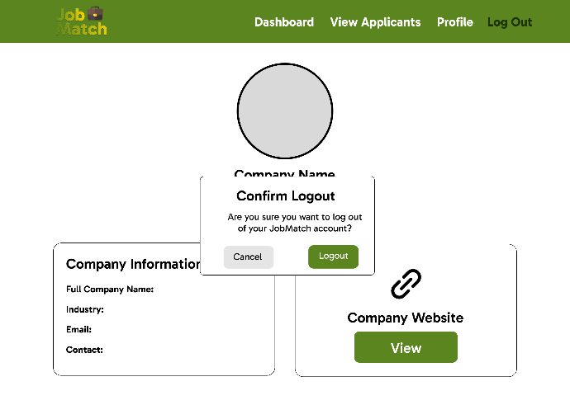
Functionalities
  - This module is where it asks the user if they are actually logging out on the website.

References
Tester
  - Test 1 – Login Module Testing
    - Test the username input
      - Result:
        - Username input failed to validate if input is empty.
    - Test the password input
      - Result:
        - Password input used type=text, it should be type=password.

  - Test 2 – Sign Up Module Testing
- Test the account creation with empty input fields
  - Result:
    - System successfully displayed an error message requiring all fields to be filled before proceeding.
- Test the role selection (Employer / Job Seeker)
  - Result:
    - Dropdown selection worked properly and directed users to their respective dashboards after registration.

- Test 3 – Job Seeker Dashboard Module Testing
- Test viewing applied jobs
  - Result:
    - Successfully displayed all applied jobs with correct job titles and statuses.
- Test search and filter functionality
  - Result:
    - Search bar and filter options accurately filtered results based on job title and application status.

- Test 4 – Find Jobs Module Testing
- Test searching for a job by keyword
  - Result:
    - The system returned relevant job posts based on entered keywords.
- Test filtering by category
  - Result:
    - Filter worked correctly and displayed jobs under the selected category.
- Test “Apply Now” button
  - Result:
    - Redirected properly to the application form page.

- Test 5 – Apply Form Module Testing
- Test submission with complete information
  - Result:
    - Form submission successful, and confirmation message displayed.
- Test submission with missing required fields
  - Result:
    - Validation prevented incomplete submission and displayed a warning message.

- Test 6 – Employer Dashboard Module Testing
- Test creating a job post
  - Result:
    - Job post successfully added and displayed in employer’s job list.
- Test editing an existing post
  - Result:
    - Updates were saved and reflected correctly on the dashboard.
- Test deleting a post
  - Result:
    - Post successfully removed from the list after confirmation.

- Test 7 – View Applicants Module Testing
- Test viewing applicants list for a specific post
  - Result:
    - All applicants displayed correctly with names and submission dates.
- Test downloading applicant attachments
  - Result:
    - Files downloaded successfully in correct format.
- Test updating application status
  - Result:
    - Status update reflected both on employer and applicant dashboards.

- Test 8 – Message Module Testing
- Test sending message from employer to applicant
  - Result:
    - Message successfully sent and appeared in applicant’s message inbox.
- Test receiving message notification
  - Result:
    - Notification icon displayed correctly upon receiving new message.

- Test 9 – Profile Module Testing (Both Employer & Job Seeker)
- Test viewing personal information
  - Result:
    - Information displayed correctly based on registered account details.
- Test editing information
  - Result:
    - Profile update successful and displayed updated data instantly.

- Test 10 – Logout Module Testing
- Test logout confirmation prompt
  - Result:
      - Confirmation box appeared before logging out.
- Test session termination after logout
  - Result:
      - Session successfully ended; returning to login page prevented access to previous session data.

